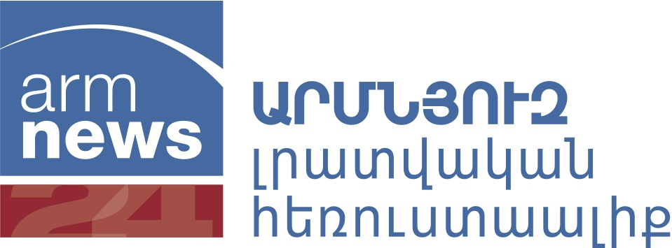

Yerevan, December 20, 2012

**PRESS RELEASE**

**PRESIDENTIAL ELECTIONS IN ARMENIA. PUBLIC OPINION POLL**

Leading Armenian media company ArmNews TV initiated and sponsored major public opinion research project, aiming at establishing and analyzing socio-political attitudes and opinions of Armenian population and track the dynamics of the electoral preference before 2013 Presidential elections. The project is implemented by Armenian Sociological Association and Baltic Surveys / The Gallup Organization in December 2012 – February 2013.

First national representative public opinion poll of this project was conducted between December 5-16, 2012 and was publically presented on December 20.

In this poll, 1,020 adult residents of Armenia, eligible to vote in the general elections, were interviewed using face-to-face in-homes interview methodology.

The response rate was 65%, the margin of error does not exceed +- 3,1% with a confidence level of 95%.

The first poll was planned in such a way, that it started just before the official campaign for the Presidential elections and allowed to measure the electoral support for possible candidates in the elections.

Dr. Rasa Alisauskiene from Gallup points out, that in the eve of the start of official campaign, Armenian voters show high interest in forthcoming Presidential elections – 42% of them said that they definitely will vote in the elections and 36% “probably will vote”. However, one should remember, that in the national poll, only the citizens of Armenia who actually are in the country are interviewed, while the electoral list includes also these, who are abroad, thus the final elections turnout in countries with high emigration rate as Armenia is usually lower than the numbers of national polls (excluding emigrants) show.

At the beginning of December, almost half of interviewed voters expressed their support for the re-election of acting President – 49% of the respondents said they would vote for Serg Sargsyan (the list of several possible candidates was presented to the respondents).

Dr. Gevorg Poghosyan of ASA comments on the poll results “TV remains the most important source of the political information for the residents of Armenia, with the importance of “word of mouth” and internet gaining importance during the official campaign”.

ArmNews TV is implementing this project with Baltic Surveys /The Gallup Organization and ASA, because Gallup is one of the most respected and well known polling organizations in the world and Baltic Surveys/The Gallup Organization is the most experienced international polling organization working in Armenia with 15 projects implemented with ASA since 2005.

**The presentation of the survey results are available on:**

[**www.asa.sci.am**](http://www.asa.sci.am) **and** [**www.armnewstv.am**](http://www.armnewstv.am)

Project leaders:

**Artak Aleksanyan, ArmNews TV** Managing producer ([www.armnewstv.am](http://www.armnewstv.am)**)**

ArmNews was established in 2001 and license for broadcasting was issued in 2003. Before 2011 ArmNews TV mainly broadcasted EuroNews TV including of elements of own production. In September 2011 ArmNews started to broadcast new own programs aiming to become the first and only 24 hours Armenian news TV channel.

**Dr. Rasa Alisauskiene, Baltic Surveys/The Gallup Organization** ([www.gallup.com](http://www.gallup.com))

Gallup (The Gallup Organization) is leading global polling and consulting company, one of the “founding fathers” of the modern public opinion polling industry. It was established by Dr. George Gallup in USA in 1935 and has grown into major worldwide company ([www.gallup.com](http://www.gallup.com)).

“Baltic Surveys” is part of Gallup, the first private independent public opinion and market research company in Lithuania, established in April 1992 as Gallup Lithuanian office. It is a member of ESOMAR, AmCham, British Chamber of Commerce, IAPC and other international organizations.

Baltic Surveys / The Gallup Organization for 20 years conducts public opinion polling and market research projects throughout Central and Eastern Europe and the CIS countries (Armenia, Belarus, Moldova, Kazakhstan, Kyrgyzstan, Georgia, Azerbaijan, Ukraine, Russia). The company is represented in ESOMAR

(R. Alisauskiene is the member since 1992). Dr.R.Alisauskiene is a board member of Gallup Europe.

**Dr. Gevorg Poghosyan, Armenian Sociological Association (**[**www.asa.sci.am**](http://www.asa.sci.am)**)**

Established in 1992, ASA - Armenian Sociological Association is the pioneer and one of the leaders among the research organizations in Armenia.   
ASA is a national member of ISA - International Sociological Association, ESOMAR, and ESA - European Sociological Association.

ASA has the best practice in Armenia, based on 20 years working experience in the following areas: social research, public opinion polls, exit polls, market research, media surveys, qualitative and quantitative research, etc. Dr.Gevorg Poghosyan is doctor, professor of sociology, corresponding member of Armenian National Academy of Sciences.